# Parts of a DataFrame - Accessing Attributes

This document includes the question, the solution, and a breakdown of the code provided in the screenshot.

## Uploaded Screenshot

Below is the screenshot of the task:

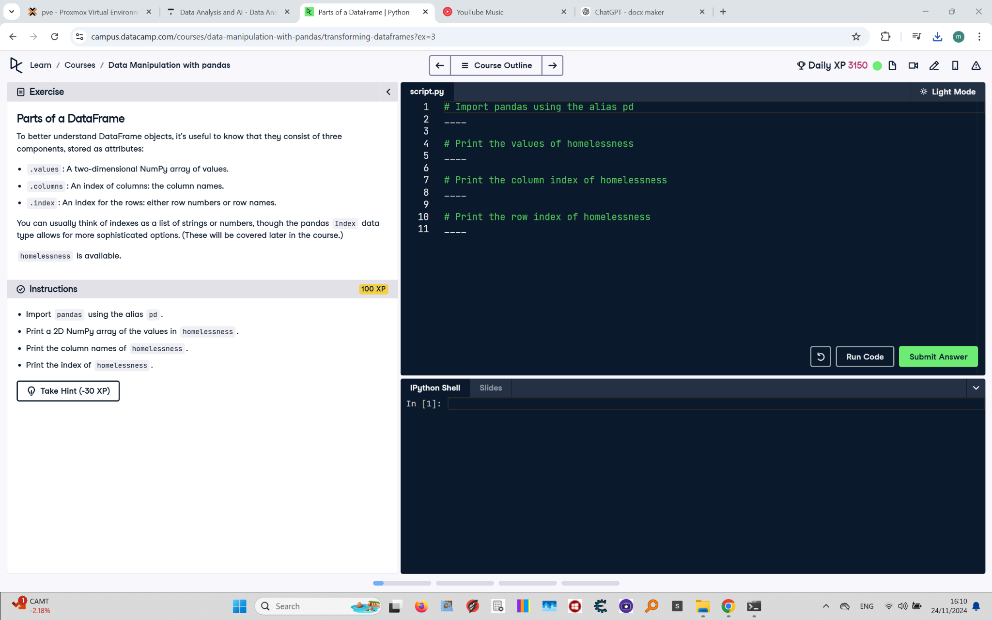

## Question

Import pandas using the alias `pd`. Print the values, column names, and row index of the homelessness DataFrame.

## Answer

# Import pandas using the alias pd  
import pandas as pd  
  
# Print the values of homelessness  
print(homelessness.values)  
  
# Print the column index of homelessness  
print(homelessness.columns)  
  
# Print the row index of homelessness  
print(homelessness.index)

## Code Explanation

# Explanation of the code:

1. `import pandas as pd`: Imports the pandas library and gives it the alias `pd` for easier use.

2. `print(homelessness.values)`: Prints the 2D NumPy array containing the underlying values of the DataFrame.

3. `print(homelessness.columns)`: Prints the column names of the DataFrame.

4. `print(homelessness.index)`: Prints the row index of the DataFrame, which can be numbers, strings, or more complex objects.